From VNet we can create service endpoints for the PaaS service we need to access (need to do a POC).

**Requirments:**

1. Resource Group
2. Network
3. Subnet within a network
4. Virtual machine create with in subnet
5. PaaS Postgress service

Create Resource Group

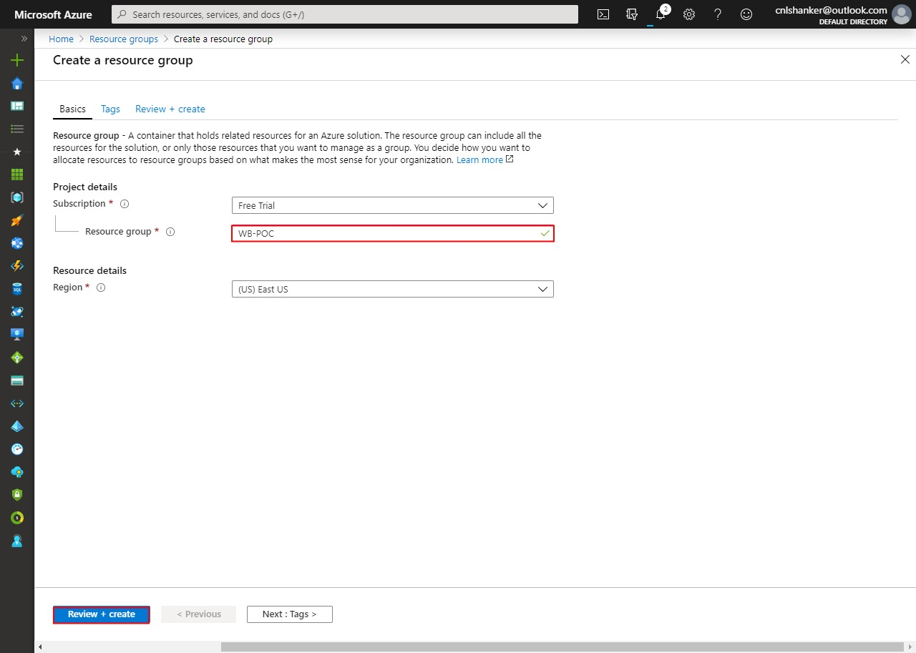



Resource group created.

Create virtual network

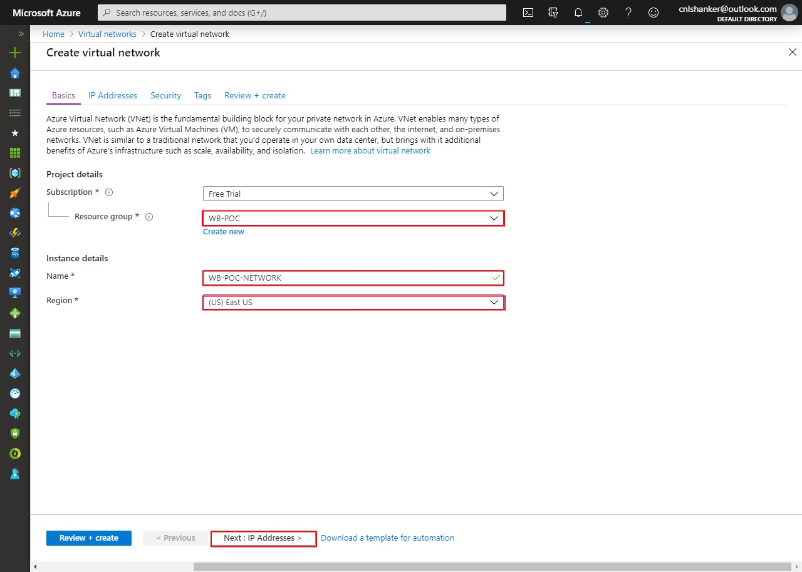

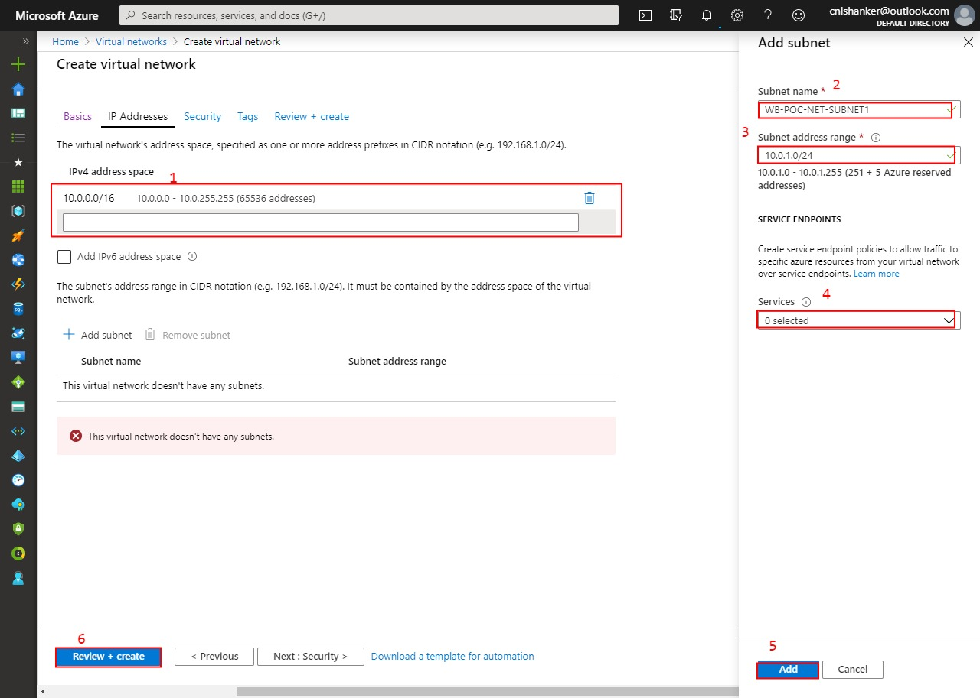

Network created.

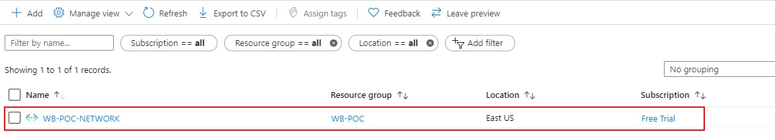

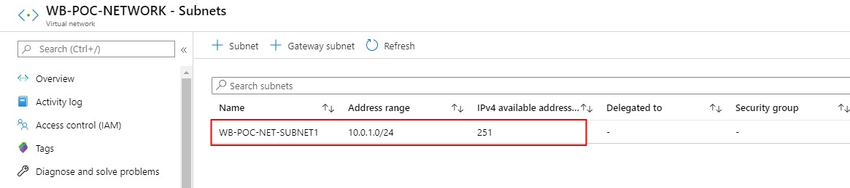

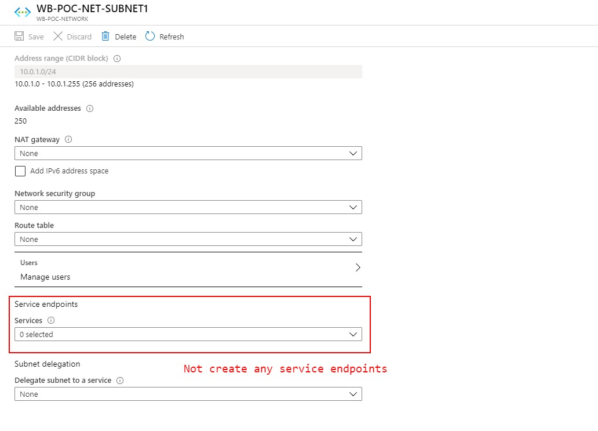

Subnet also created with in network and not created any service point.

To Create virtual machine in existing virtual Network

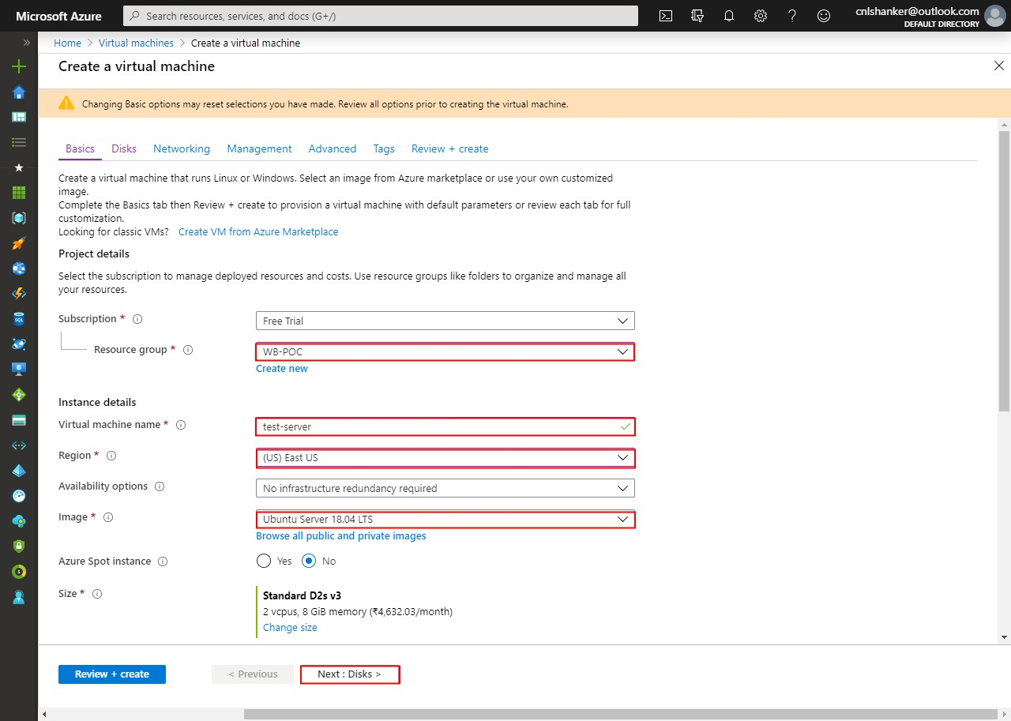

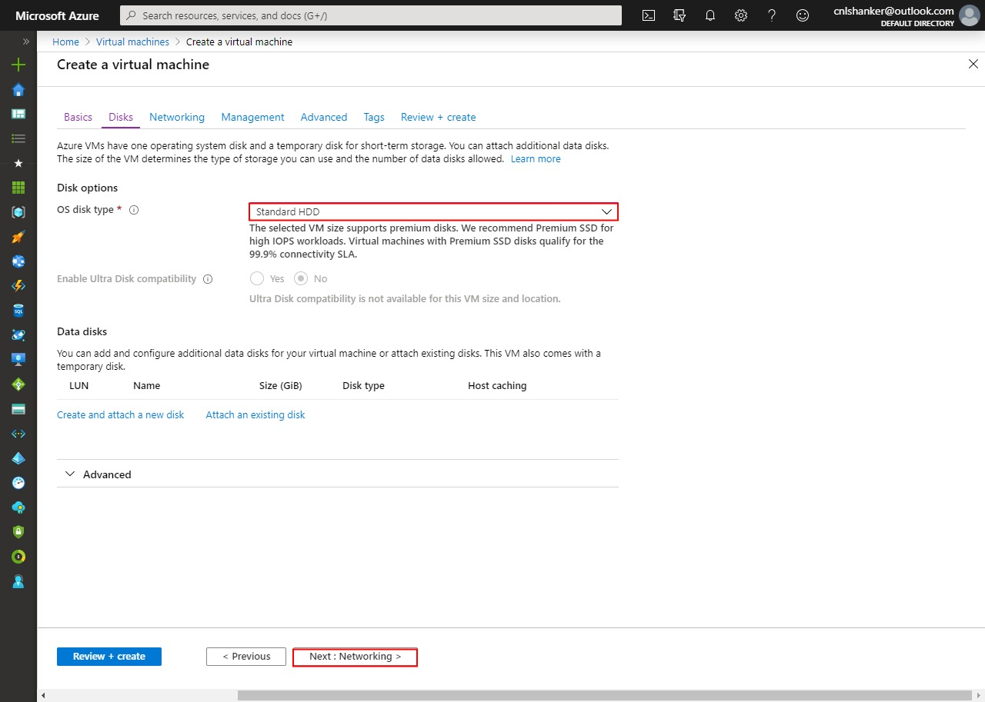

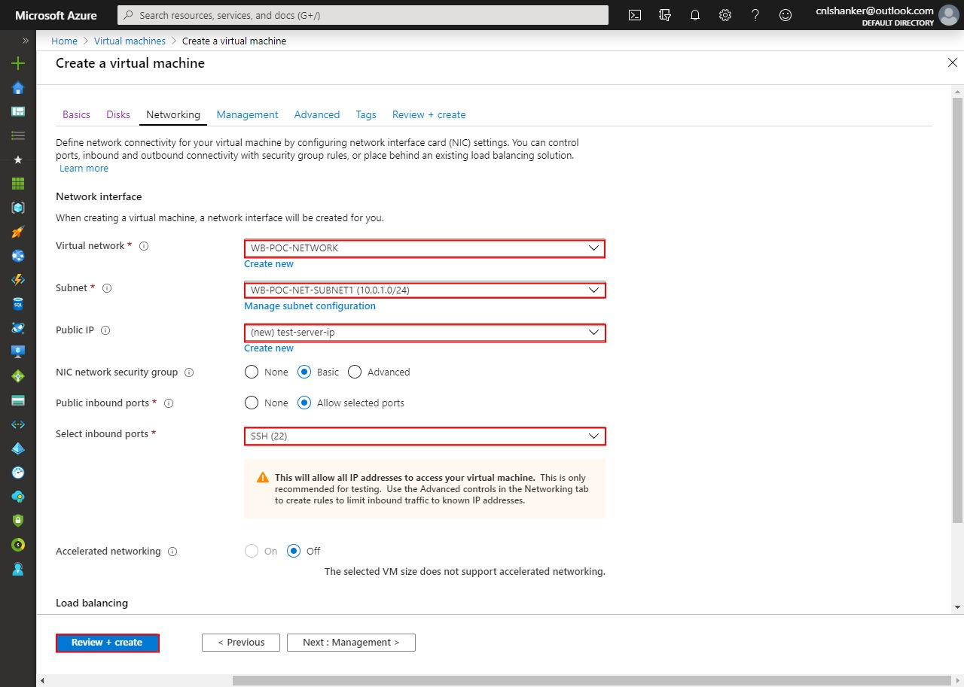

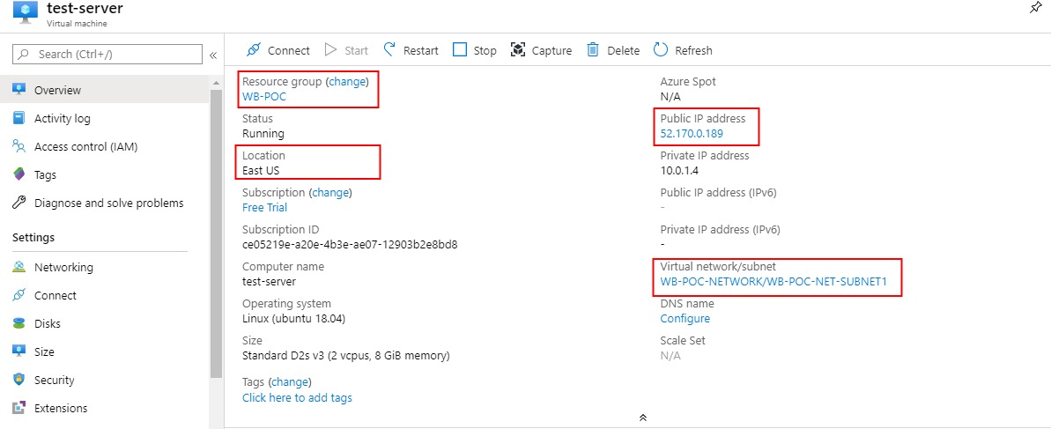

VM created done.

Check with test-server inbound Rule

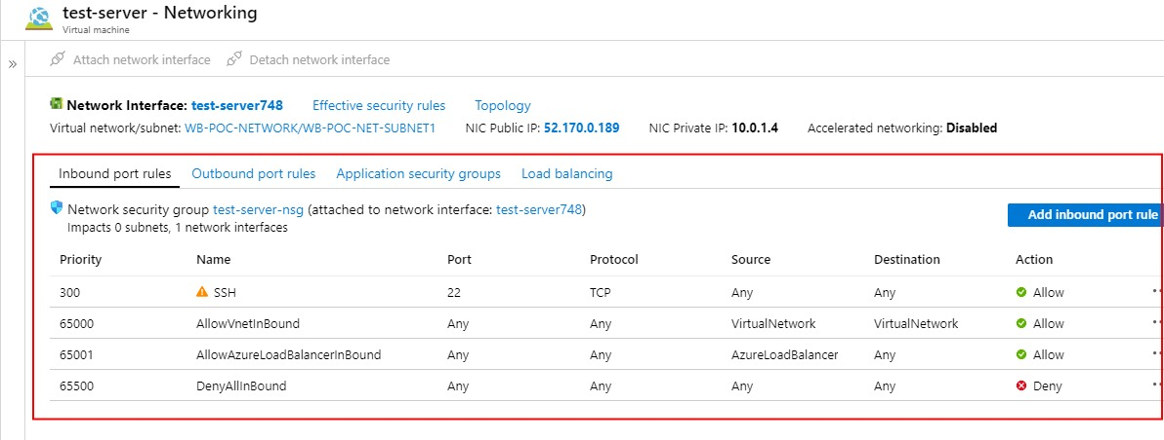

Check with test-server outbound rule

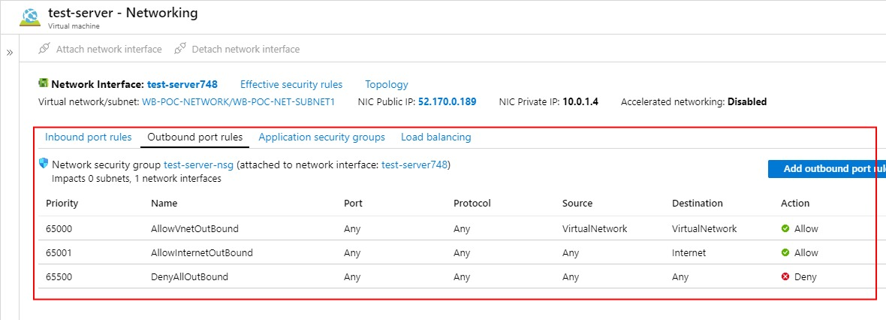

to take remote ssh-server

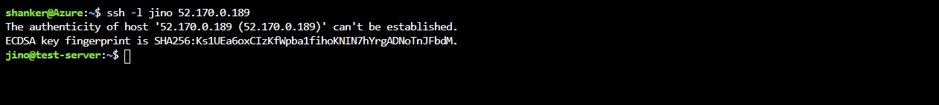

To create Postgress Database as PaaS services

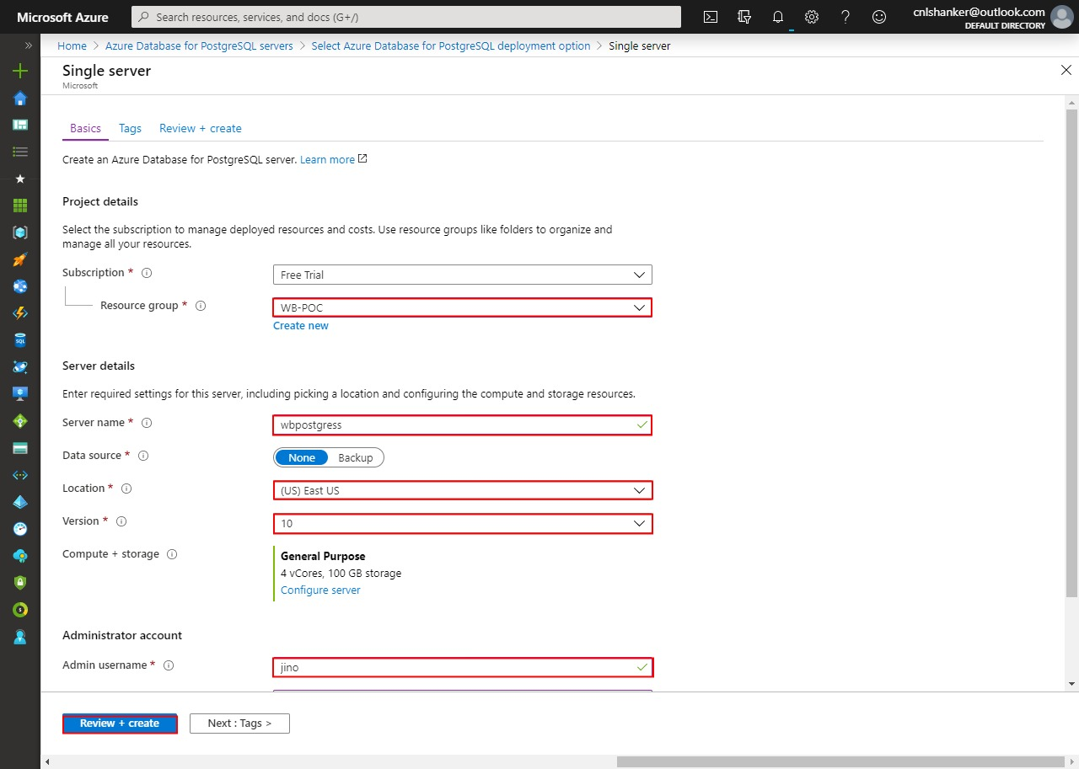

This is postgress server

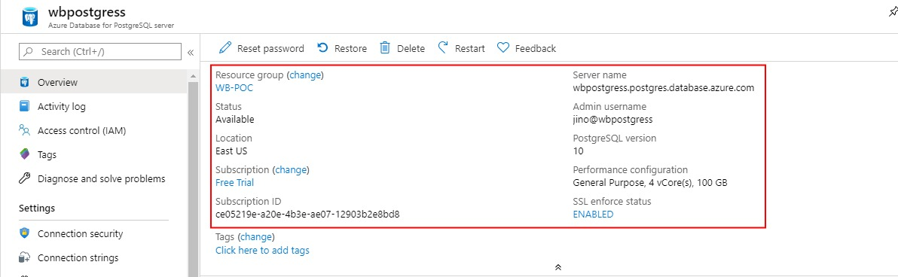

No Rules apply in Postgress

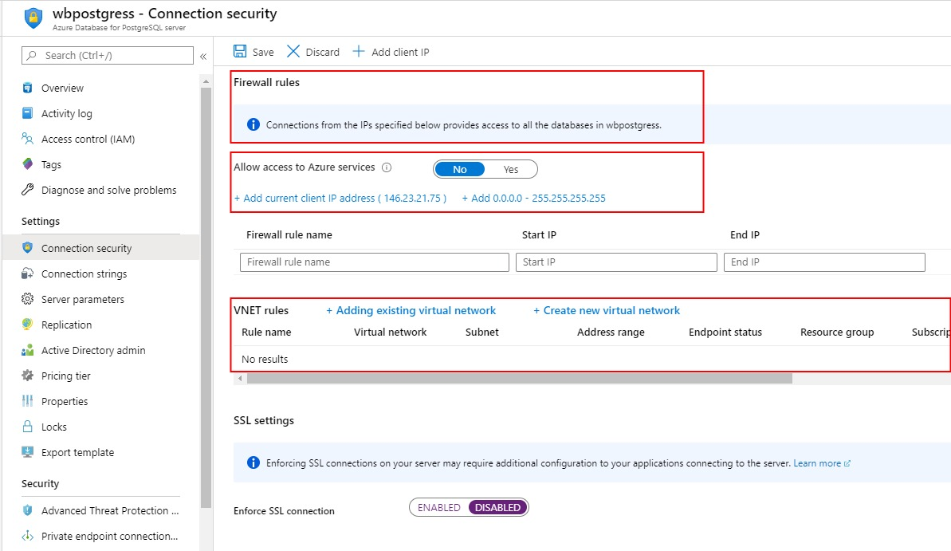

Create VNET Rules in postgress.

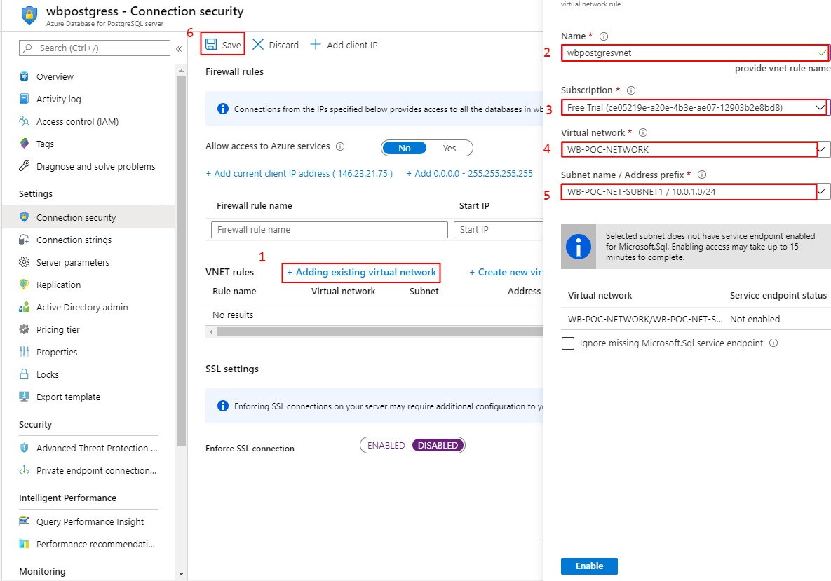

VNET rules apply to particular subnet.

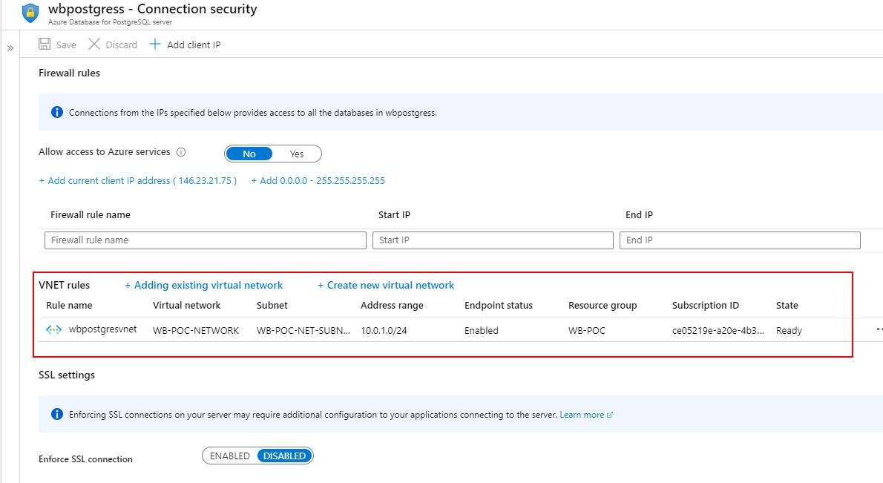

VNET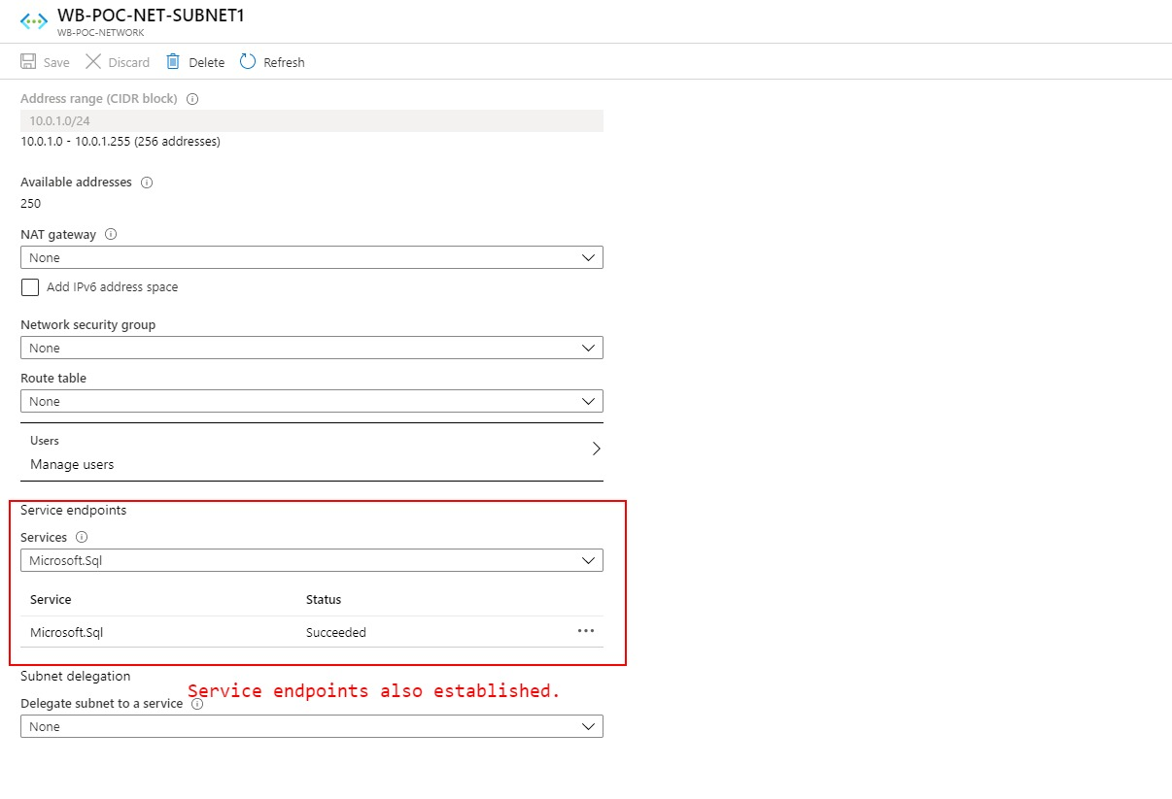

VNET RULES CREATE.

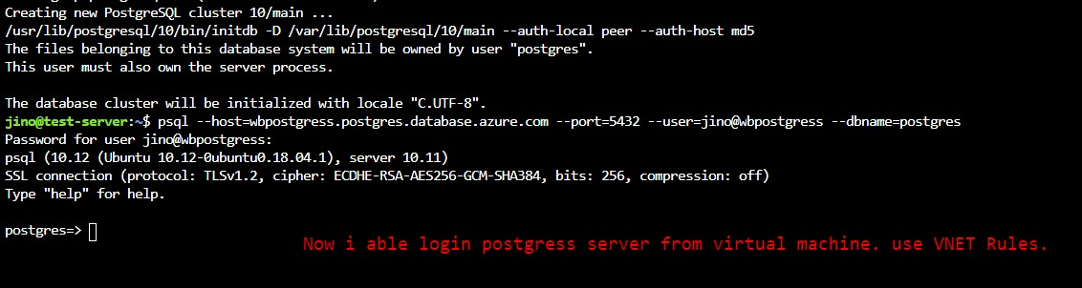

Second scenario: Allow access to azure services

Note: Old rules are remove.





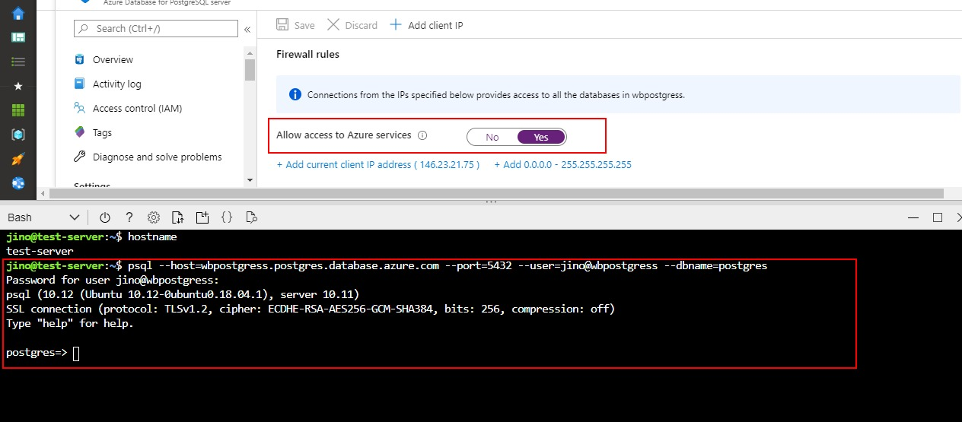

Third scenario: Service endpoint.

Now I go to virtual network and select subnet

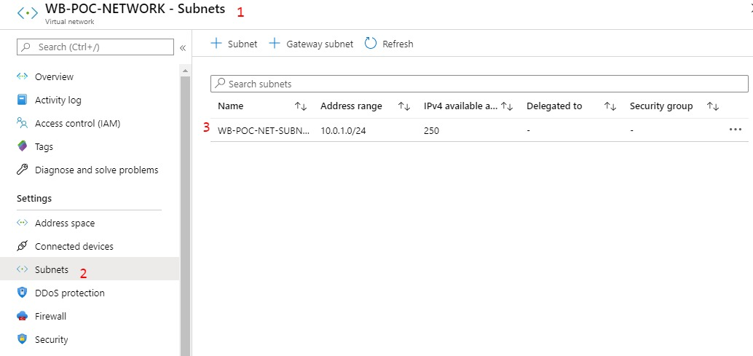

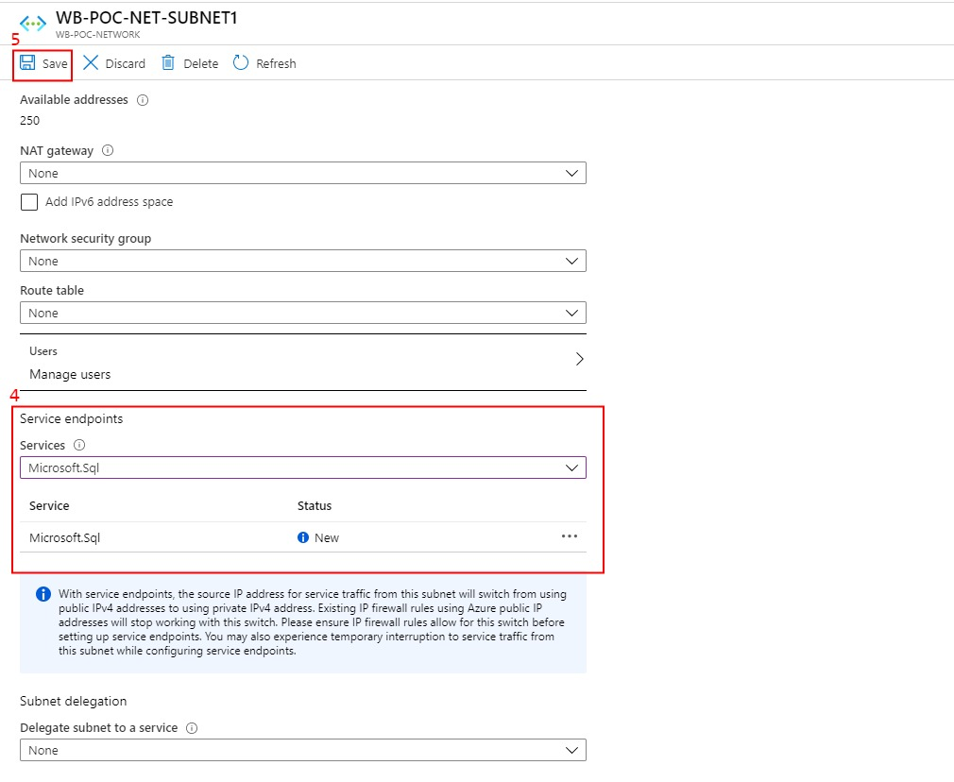

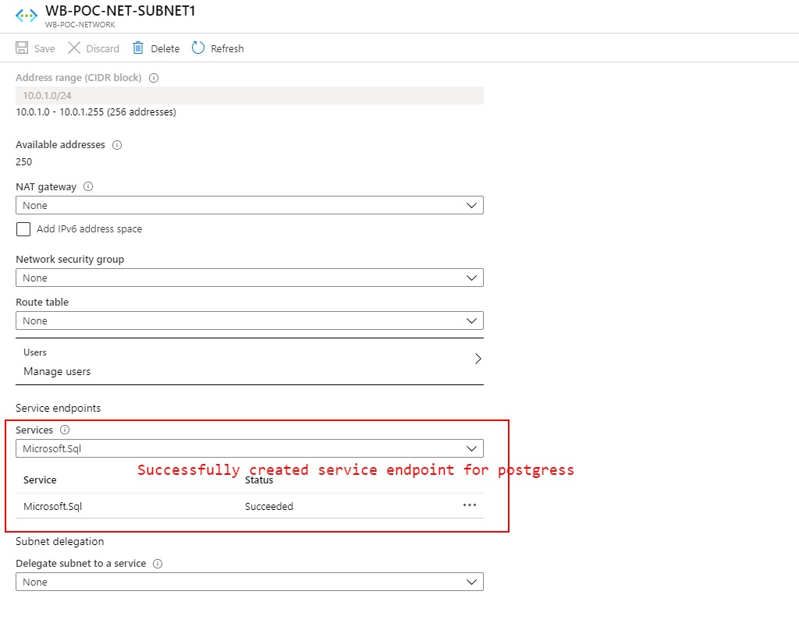

Now I go to virtual machine to change security group.

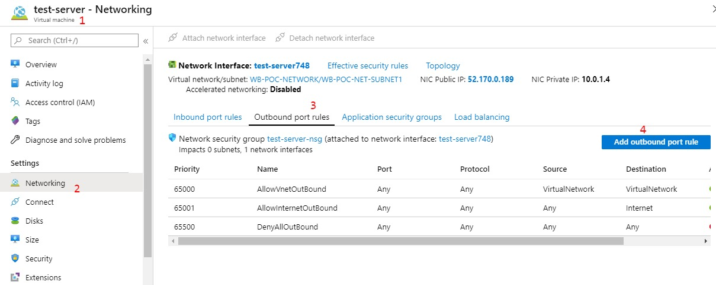

To change SQL services access SECURITY POLICY

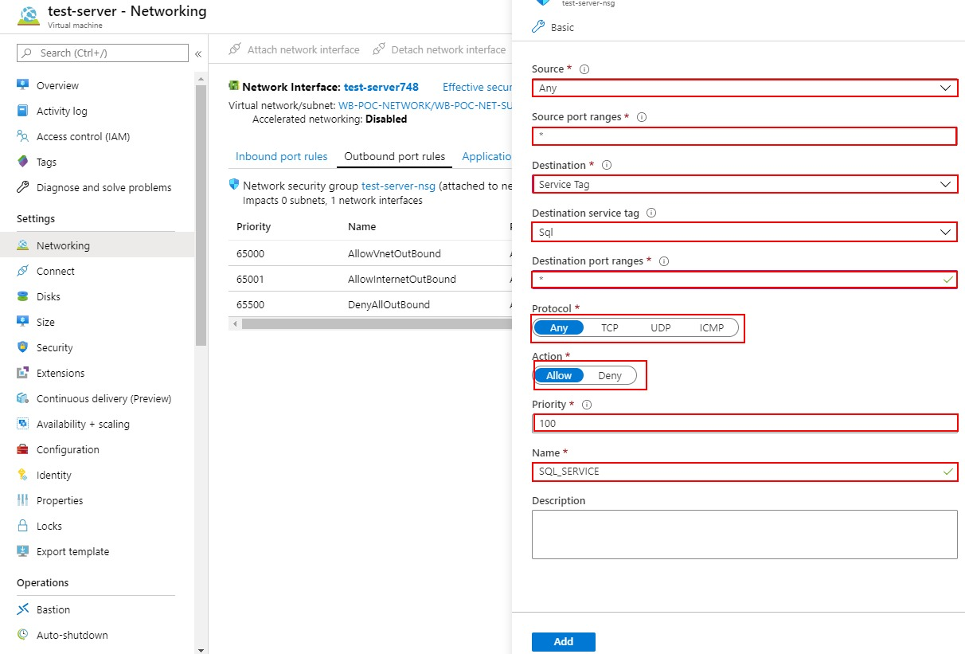

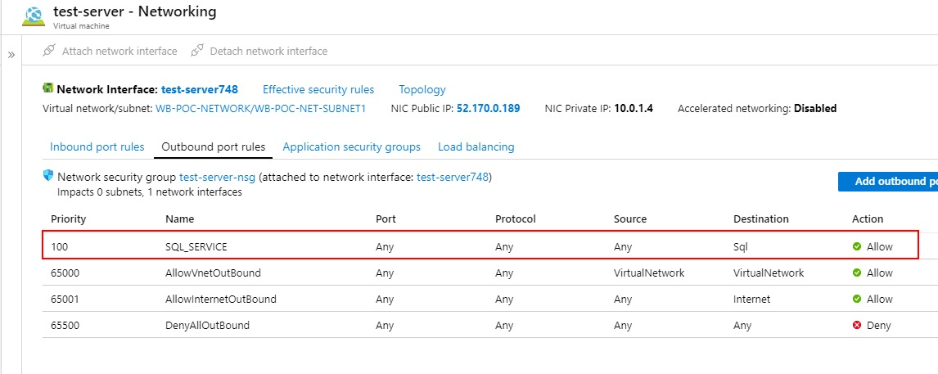

Sql rule was attached to test-server. Now I able to connect postgress server from test-server.

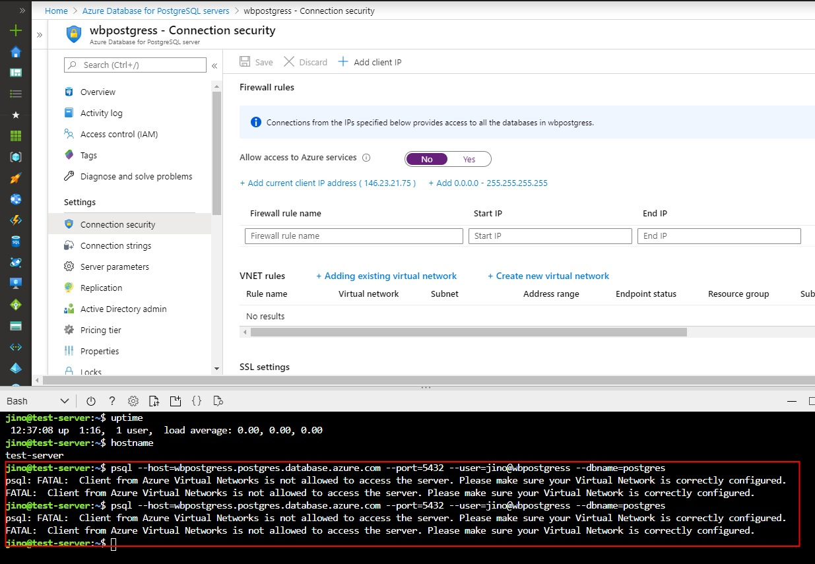

This scenario not working